Họ và tên : Vũ Văn Trọng

Mã số sinh viên : 20184206

ASSIGNMENT 2

#Laboratory Exercise 7, Home Assignment 2

.text

main:

li $a0,2 #load test input

li $a1,6

li $a2,9

jal max #call max procedure

nop

endmain:

#---------------------------------------------------------------------

#Procedure max: find the largest of three integers

#param[in] $a0 integers

#param[in] $a1 integers

#param[in] $a2 integers

#return $v0 the largest value

#---------------------------------------------------------------------

max:

add $v0,$a0,$zero #copy (a0) in v0; largest so far

sub $t0,$a1,$v0 #compute (a1)-(v0)

bltz $t0,okay #if (a1)-(v0)<0 then no change

nop

add $v0,$a1,$zero #else (a1) is largest thus far

okay:

sub $t0,$a2,$v0 #compute (a2)-(v0)

bltz $t0,done #if (a2)-(v0)<0 then no change

nop

add $v0,$a2,$zero #else (a2) is largest overall

done:

jr $ra #return to calling program

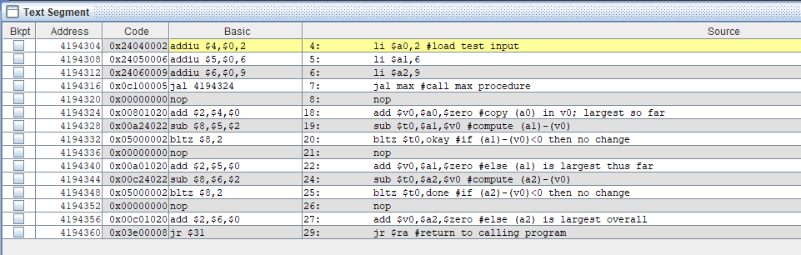

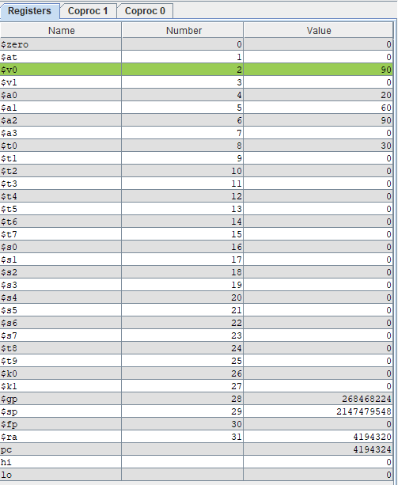

Ta có thể thấy giá trị max là 90